**Functional Document**

|  |  |
| --- | --- |
| **Application** | NGERP - Centra |
| **Service Bundle** | Purchase Management |
| **Service Request** | Generate NTA AP Payment |

**Description:**

The "**Generate NTA AP Payment**" service request in **Compiere** (**NGERP** - **Centra)** allows users to generate payments for accounts payable (AP) based on selected invoices. This process automates payment transactions from outstanding invoices, ensuring accurate payment processing.

**Workflow Process:**

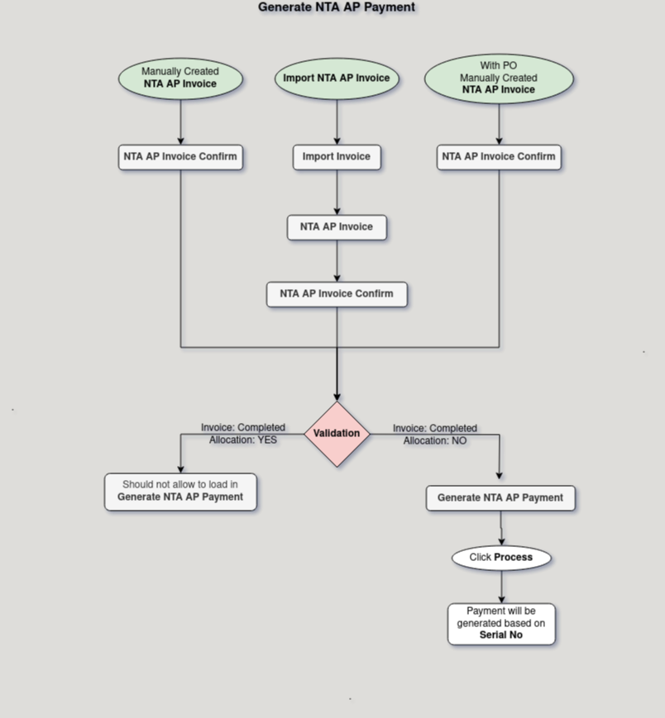

**Business Rules:**

* It is visible only in **HQ.**
* Creation is also possible in **HQ.**
* Only invoices with an outstanding balance can be selected for payment generation.
* Only fully unpaid invoices can be selected for payment generation.
* Valid payment methods must be configured for the payment generation process to proceed.
* Invoices marked as paid or closed will be excluded from the payment generation list.